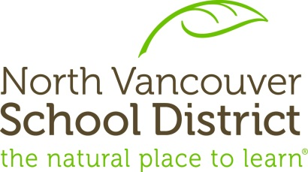

The Continuum of Social Emotional Learning
https://vibrantlearning.ca/district-planning/social-emotional-learning/

“We know from human history and the latest learning science that success comes from the combination of academic knowledge and the ability to work with others. We need public education to reflect this.” Walter Isaacson, Aspen Institute
Preamble
The North Vancouver School District is committed to a continuum of SEL integral to student well-being and development. The continuum includes creating a Sense of Belonging for students, teaching of Pro-Social Skills, Positive Mental Health awareness, and an Integrated Service Approach to Mental Health.
Each area of SEL support is beneficial on its own, but the development of strategic action across the continuum provides a comprehensive focus and best meets the needs of all students.

Sense of Belonging
A positive sense of belonging nurtures self-esteem, self-worth, and ultimately equips young people with the ability to develop healthy relationships with others (Brokenleg, 2002). When we are anchored in community, we develop self-esteem assuring ourselves of our own worth as individuals (Maslow, 1943). Relationships with peers and school staff based on mutual trust and respect are essential to engagement and learning.
Goal: To ensure students have connection(s) to a member of school staff.

Social Emotional Learning
Schools help children and adults acquire and apply knowledge, skills, and attitudes that enhance personal development, establish satisfying interpersonal relationships, and lead to effective and ethical work and productivity. These include: 1) competencies to understand and manage emotions; 2) set and achieve positive goals; 3) feel and show caring and concern for others; 4) establish and maintain positive relationships; and 5) make responsible decisions.
Goal: Promote educator awareness and teaching of evidence-based strategies to develop student Self-Awareness, Self-Management, Social Awareness, Relationship Skills, and Responsible Decision-Making.

Mental Health Literacy
In order to raise confident, self-assured, and well-rounded individuals, a holistic approach to teaching both brains and bodies about how to keep brains and bodies healthy and well is essential. Mental Health Literacy is an essential component of this holistic approach and is defined as: 1) understanding how to foster and maintain good mental health; 2) understanding mental disorders and their treatments; 3) decreasing stigma about mental illness; and 4) understanding how to seek help effectively.
Goal: All students in the North Vancouver School District will receive mental health literacy training before they leave secondary school and enter post-secondary school or pursue their career pathways.

Integrated Mental Health
The presence of social, emotional, behavioural, or mental health concerns neither occur overnight, nor in isolation. Given the complexity of youth mental health, a coordinated and integrated approach to support is essential. In partnership with community agencies in a wraparound support model, school staff and families are able to ensure a higher quality of care. Key to this support is clear and consistent communication despite the need to broaden the team to beyond school for students in need.
Goal: Achieve effective communication and collaborative action between schools and community agencies to ensure seamless levels of mental health care and support for students and their families.

The Continuum of Social Emotional Learning
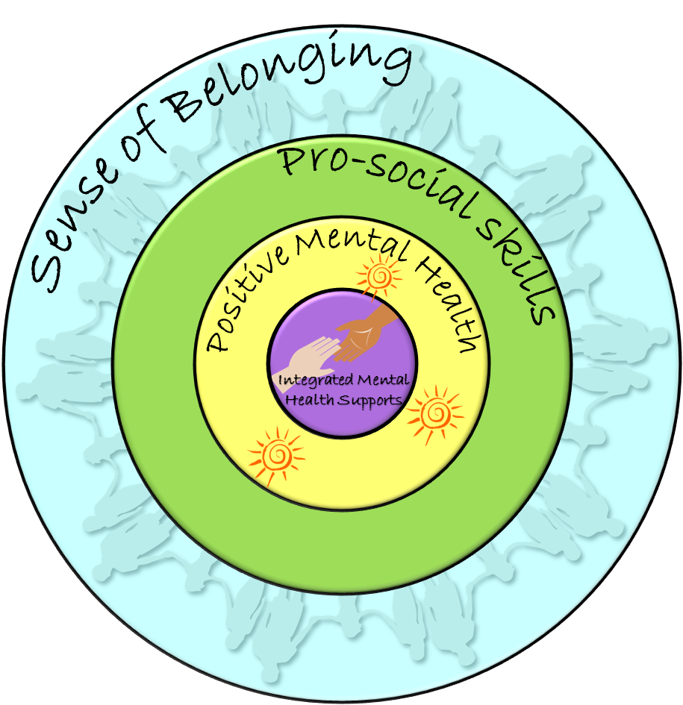

Sense of Belonging – an intentional focus on strategies and structures that ensure each and every student feels a sense of belonging and connection with their classmates, teachers, and school
Pro-Social Skills – using the CASEL Framework, intentionally teaching students the key social emotional skills to be successful
Positive Mental Health – through the use of Dr. Stan Kutcher’s curriculum, improving mental health literacy for all grade 9 students district-wide and providing teachers a shared language in promoting positive mental health
Integrated Mental Health Supports – developing strategic partnerships with inter-ministerial partners to create seamless supports for children and youth with mental health needs

